**Project Planning Phase**

|  |  |
| --- | --- |
| Date | 26 october 2022 |
| Team ID | PNT2022TMID49935 |
| Project Name | Plasma Donar Application |

Product Backlog, Sprint Schedule, and Estimation :

|  |  |  |  |  |  |  |
| --- | --- | --- | --- | --- | --- | --- |
| **Sprint** | **Functional**  **Requirement(Epic)** | **User Story**  **Number** | **User Story/Task** | **Story point** | **Priority** | **Team Members** |
| Sprint-1 | Registration | USN-2 | As a user, I can register for the application by entering my email, password, and confirming my password. | 2 | High | Vignesh.j |
| Sprint-1 |  | USN-2 | As a user, I will receive confirmation email once I have register for the application | 1 | High | Vishnu prasath.L |
| Sprint-2 |  | USN-3 | As a user, I can register for the application through Aadhar Number | 2 | Low | Sudalai Raj.S |
| Sprint-1 |  | USN-4 | As a user, I can register for the application through Gmail | 2 | Medium | Selvamayil venkadesh.R |
| Sprint-1 | Login | USN-5 | As a user, I can log into the application by entering email & password | 1 | High | Vignesh.J |

**Project Tracker, Velocity & Burndown Chart:**

|  |  |  |  |  |  |  |
| --- | --- | --- | --- | --- | --- | --- |
| **Sprint** | **Total Story point** | **Duration** | **Sprint Start Date** | **Sprint End Date (Planned)** | **Story Point Completed (as on Planned End Date)** | **Sprint Release Date (Actual)** |
| Sprint-1 | 20 | 6 Days | 26 Oct 2022 | 31 Oct 2022 | 20 | 31 Oct 2022 |
| Sprint-2 | 20 | 6 Days | 1 Nov 2022 | 6 Nov 2022 | 20 | 6 Nov 2022 |
| Sprint-3 | 20 | 6 Days | 7 Nov 2022 | 12 Nov 2022 | 20 | 12 Nov 2022 |
| Sprint-4 | 20 | 6 Days | 13 Nov 2022 | 18 Nov 2022 | 20 | 18 Nov 2022 |

**Velocity:**

AV = Sprint duration/velocity

= 20/6 = 3.33

**Burndown chart:**

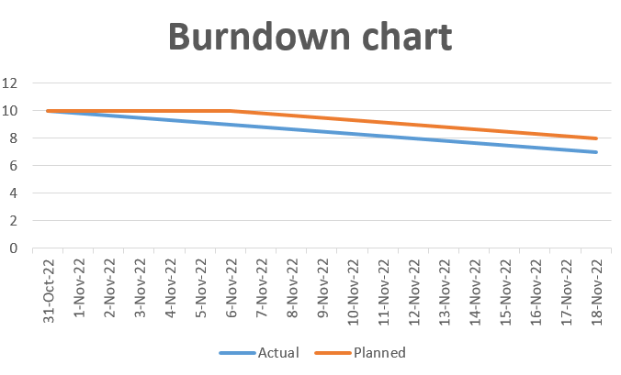

**Reference:**

<https://www.atlassian.com/agile/project-management>

<https://www.atlassian.com/agile/tutorials/how-to-do-scrum-with-jira-software>

<https://www.atlassian.com/agile/tutorials/epics>

<https://www.atlassian.com/agile/tutorials/sprints>

<https://www.atlassian.com/agile/project-management/estimation>

<https://www.atlassian.com/agile/tutorials/burndown-chart>